**Basic Financial Statements**

Before we begin building projected financial statements, it would be helpful to review the basic

financial reports that measure a company’s financial position: the balance sheet, the income state

ment, and the statement of cash flows. The level of financial sophistication among small business

owners may not be high, but the extent of financial reporting among small businesses is. Most

small businesses regularly produce summary financial information, almost all of it in the form of

these traditional financial statements.

**The Balance Sheet**

Like a digital camera, the balance sheet takes a “snapshot” of a business’s financial position,

providing owners with an estimate of its worth on a given date. Its two major sections show the

assets the business owns and the claims creditors and owners have against those assets. The bal-

ance sheet is usually prepared on the last day of the month. Figure 11.1 shows the balance sheet

for Sam’s Appliance Shop for the year ended December 31, 2015.

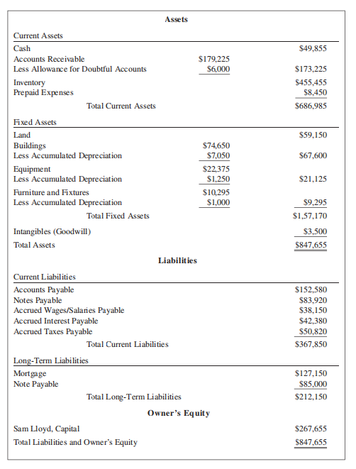

The balance sheet is built on the fundamental accounting equation: Assets = Liabilities +

Owner’s equity. Any increase or decrease on one side of the equation must be offset by an in

crease or decrease on the other side, hence the name *balance sheet*. It provides a baseline from

which to measure future changes in assets, liabilities, and equity. The first section of the balance

sheet lists the company’s assets (valued at cost, not actual market value) and shows the total value

of everything the business owns. Current assets consist of cash and items to be converted into

cash within one year or within the normal operating cycle of the company, whichever is longer,

such as accounts receivable and inventory. Fixed assets are those acquired for long-term use

in the business. Intangible assets include items such as goodwill, copyrights, and patents that,

although valuable, are not tangible.

The second section shows the business’s liabilities—the creditors’ claims against the com

pany’s assets. Current liabilities are those debts that must be paid within one year or within the

normal operating cycle of the company, whichever is longer, and long-term liabilities are those

that come due after one year. This section of the balance sheet also shows the owner’s equity, the

value of the owner’s investment in the business. It is the balancing factor on the balance sheet,

representing all of the owner’s capital contributions to the business plus all accumulated (or

retained) earnings not distributed to the owner(s).

**The Income Statement**

The income statement (also called the profit-and-loss statement) compares expenses against

revenue over a certain period of time to show the firm’s net income (or loss). Like a digital video

recorder, the income statement is a “moving picture” of a company’s profitability over time.

The annual income statement reports the bottom line of the business over the fiscal or calendar

year. Figure 11.2 shows the income statement for Sam’s Appliance Shop for the year ended

December 31, 2015.

To calculate net income or loss, an entrepreneur records sales revenues for the year, which includes all income that flows into the business from sales of goods and services. Income from other

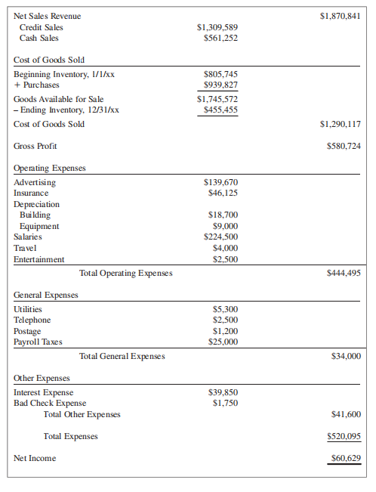

sources (rent, investments, and interest) also must be included in the revenue section of the income

statement. To determine net sales revenue, owners subtract the value of returned items and refunds

from gross revenue. Cost of goods sold represents the total cost, including shipping, of the mer

chandise sold during the accounting period. Manufacturers, wholesalers, and retailers calculate cost

of goods sold by adding purchases to beginning inventory and subtracting ending inventory. Ser-

vice-providing companies typically have no cost of goods sold because they do not carry inventory.

Subtracting the cost of goods sold from net sales revenue results in a company’s gross profit.

Allowing the cost of goods sold to get out of control whittles away a company’s gross profit and

threatens its ability to generate positive net income because a company must pay all of its operat

ing expenses out of its gross profit. Dividing gross profit by net sales revenue produces the gross

profit margin, a ratio that every small business owner should watch closely. If a company’s gross

profit margin slips too low, it is likely that it will operate at a loss (negative net income). A business that operates at a gross profit margin of 50 percent must generate $2 in sales for every $1 of

operating expenses just to break even. However, a company with a 10 percent gross profit margin

must generate $10 in sales for every $1 of operating expenses to reach its break-even point.

Many business owners whose companies are losing money mistakenly believe that the prob

lem is inadequate sales volume; therefore, they focus on pumping up sales at any cost. In many

cases, however, the losses their companies are incurring are the result of an inadequate gross

profit margin, and pumping up sales only deepens their losses! Repairing a poor gross profit

margin requires a company to raise prices, cut manufacturing or purchasing costs, refuse orders

with low profit margins, “fire” unprofitable customers (see Figure 11.3), or add new products

with more attractive profit margins. *Increasing sales will not resolve the problem.* Monitoring the

gross profit margin over time and comparing it to those of other companies in the same industry

are important steps to maintaining a company’s long-term profitability.

**The Statement of Cash Flows**

The statement of cash flows show the changes in a company’s working capital from the beginning of the accounting period by listing both the sources of funds and the uses of those funds.

Many small businesses never need to prepare such a statement; instead, they rely on a cash

budget, a less formal managerial tool you will learn about in Chapter 12 that tracks the flow of

cash into and out of a company over time. Sometimes, however, creditors, lenders, investors, or

business buyers may require this information.

To prepare the statement, owners must assemble the balance sheet and the income statement

summarizing the present year’s operations. They begin with the company’s net income for the

period (from the income statement). Then they add the sources of the company’s funds: borrowed

funds, owner contributions, decreases in accounts receivable, increases in accounts payable,

decreases in inventory, depreciation, and any others. Depreciation is listed as a source of funds

because it is a non cash expense that has already been deducted as a cost of doing business.

Because the owner has already paid for the item being depreciated, however, its depreciation is a

source of funds. Next the owner subtracts the uses of these funds: plant and equipment purchases,

dividends to owners, repayment of debt, increases in accounts receivable, decreases in accounts

payable, increases in inventory, and so on. The difference between the total sources and the total

uses is the increase or decrease in working capital. By investigating the changes in their companies’ working capital and the reasons for them, owners can create a more practical financial action plan for the future of the enterprise.

These financial statements are more than just complex documents used only by accountants

and financial officers. When used in conjunction with the analytical tools described in the fol

lowing sections, they can help entrepreneurs to map a firm’s financial future and actively plan

for profit. Mere preparation of these statements is not enough, however; owners and employees

must *understand and use* the information contained in them to make the business more effective

and efficient.

**Creating Projected Financial Statements**

Creating projected financial statements helps entrepreneurs to transform their business goals into

reality. These projected financial statements answer questions such as the following: What profit

can the business expect to earn? If the owner’s profit objective is *xx* dollars, what sales level must

the company achieve? What fixed and variable expenses can the owner expect at that level of

sales? The answers to these and other questions are critical in formulating a functional financial

plan for the small business.

This section focuses on creating projected income statements and balance sheets for a small

start-up. These projected (or pro forma) statements are a crucial component of every business plan

because they estimate the profitability and the overall financial condition of a company in the fu

ture. They are an integral part of convincing potential lenders and investors to provide the financing

needed to get the company off the ground (the topic of Chapter 13). In addition, because these state

ments project a company’s financial position through the end of the forecasted period, they help

entrepreneurs to plan the route to improved financial strength and healthy business growth. To be

useful, however, these forecasts must be *realistic and well researched*! Entrepreneurs typically find

that revenues are the most difficult to forecast. However, even though estimating future revenues is

challenging, the accuracy of these forecasts can make or break a business as it grows.

Because an established business has a history of operating data from which to construct pro-

jected financial statements, the task is not nearly as difficult as it is for a start-up company. When

creating pro forma financial statements for a business start-up, entrepreneurs typically rely on pub

lished statistics that summarize the operation of similar-size companies in the same industry. These

statistics are available from a number of sources (described later), but this section draws on in-

formation found in the *Annual Statement Studies*, a compilation of financial data collected from

250,000 companies across more than 760 industries organized by Standard Industrial Classification

(SIC) Code and North American Industry Classification System (NAICS) published by the Risk

Management Association (RMA). Because conditions and markets change so rapidly, entrepreneurs

developing financial forecasts for start-ups should focus on creating projections for two years into

the future. Although these sources offer guidelines to gauge how reasonable a company’s projections

are, entrepreneurs should use values that apply to their own particular circumstances to derive their

forecasts. Remember that any published financial data is based on operating businesses. For a start

up company, the key is accurate forecasts that show how the business will get to these industry stan-

dards. Investors want to see that entrepreneurs have developed well-researched, realistic expectations

about their companies’ income and expenses and when they expect to start earning a profit.

**Projected Financial Statements for a Small Business**

One of the most important tasks confronting the entrepreneur launching a new enterprise is to

determine the amount of funding required to begin operation as well as the amount required to

keep the company going until it begins to generate positive cash flow. The amount of money

needed to begin a business depends on the type of operation, its location, inventory requirements,

sales volume, and many other factors. Every new firm must have enough capital to cover all

start-up costs, including funds to rent or buy plant, equipment, and tools, and to pay for advertis

ing, wages, licenses, utilities, and other expenses. In addition, an entrepreneur must maintain a

reserve of capital to carry the company until it begins to generate positive cash flow. Too often,

entrepreneurs are overly optimistic in their financial plans and fail to recognize that expenses

initially exceed income (and cash outflow exceeds cash inflow) for most small firms. This period

of net losses (and negative cash flow) is normal and may last from just a few months to several

years. During this time, entrepreneurs must be able to pay the company’s regular bills, meet pay-

roll, purchase inventory, take advantage of cash discounts, pay the company’s regular bills, grant

customers credit, and meet their personal financial obligations.

**Ratio Analysis**

Would you be willing to drive a car on an extended trip without being able to see the dashboard

displays showing fuel level, engine temperature, oil pressure, battery status, or the speed at

which you were traveling? Not many people would! Yet many small business owners run their

companies exactly that way. They never take the time to check the vital signs of their businesses

using their “financial dashboards.” The result: their companies develop engine trouble, fail,

and leave them stranded along the road to successful entrepreneurship. To avoid becoming a

failure statistic, entrepreneurs must understand the numbers that drive their businesses. Norm

Brodsky, a successful serial entrepreneur, says business owners develop a feel for their financial statements and the specific numbers that they must watch closely to ensure their companies’

success. By watching the numbers over time, successful entrepreneurs learn to identify patterns

that can signal problems in their businesses.

**Twelve Key Ratios**

In keeping with the idea of simplicity, we will describe 12 key ratios that enable most business

owners to monitor their companies’ financial positions without becoming bogged down in finan-

cial details. This section presents explanations of these ratios and examples based on the balance

sheet and the income statement for Sam’s Appliance Shop shown in Figure 11.1 and Figure 11.2.

We will group them into four categories: liquidity ratios, leverage ratios, operating ratios, and

profitability ratios.

**LIQUIDITY RATIOS** Liquidity ratios tell whether a small business will be able to meet its short

term financial obligations as they come due. These ratios forewarn a business owner of impending

cash flow problems. A small company with solid liquidity not only is able to pay its bills on time

but also has enough cash to take advantage of attractive business opportunities as they arise.

**1. Current Ratio.** The current ratio measures a small firm’s solvency by indicating its ability to

pay current liabilities (debts) from current assets. It is calculated in the following manner:

Current ratio = Current assets/Current liabilities

**2. Quick Ratio.** The current ratio sometimes can be misleading because it does not reflect the

*quality* of a company’s current assets. As we have already seen, a company with a large number

of past-due receivables and stale inventory could boast an impressive current ratio and still be on

the verge of financial collapse. The quick ratio (sometimes called the acid test ratio) is a more

conservative measure of a company’s liquidity because it shows the extent to which its most

liquid assets cover its current liabilities. This ratio includes only a company’s “quick assets”—

those assets that a company can convert into cash immediately if needed—and excludes the most

illiquid asset of all, inventory. It is calculated as follows:

Quick ratio = Quick assets /Current liabilities

1. **Debt Ratio.** A small company’s debt ratio measures the percentage of total assets financed by

its creditors compared to its owners. The debt ratio is calculated as follows:

Debit ratio = Total debt (or liabilities) / Total assets

**4. Debt-to-Net-Worth Ratio.** A small company’s debt-to-net-worth (debt-to-equity) ratio

also expresses the relationship between the capital contributions from creditors and those from

owners and measures how highly leveraged a company is. This ratio reveals a company’s capital

structure by comparing what the business “owes” to “what it is worth.” It is a measure of a small

company’s ability to meet both its creditor and owner obligations in case of liquidation. The debt

to-net-worth ratio is calculated as follows:

**Debt-to-net worth ratio = Total debt (or liabilities) / Tangible net worth**

Total debt is the sum of current liabilities and long-term liabilities, and tangible net worth

represents the owners’ investment in the business (capital + capital stock + earned surplus +

retained earnings) less any intangible assets (e.g., goodwill) the firm owns.

The higher this ratio, the more leverage a business is using and the lower the degree of protection afforded creditors if the business should fail. A higher debt-to-net-worth ratio also means

that the firm has less capacity to borrow; lenders and creditors see the firm as being “borrowed

up.” Conversely, a low ratio typically is associated with a higher level of financial security, giving

the business greater borrowing potential.

**5. Times-Interest-Earned Ratio.** The times-interest-earned ratio is a measure of a small

company’s ability to make the interest payments on its debt. It tells how many times a company’s

earnings cover the interest payments on the debt it is carrying. This ratio measures the size of the

cushion a company has in covering the interest cost of its debt load. The times-interest-earned

ratio is calculated as follows:

**Times interest earned ratio = Earnings before interest and taxes (EBIT) / Total interest expense**